Chapter 1: Introduction to Student Attendance System 3
1.1 Background 3
1.2 Statement of Problem 3
1.3 Purpose of the Project 4
1.4 Objectives 4
1.4.1 General Objective 4
1.4.2 Specific Objectives 4
1.5 Feasibility Study 5
1.5.1 Technical Feasibility 5
1.5.2 Economic Feasibility 5
1.5.3 Operational Feasibility 5
1.5.4 Schedule Feasibility 6
1.6 Scope and Limitation 6
1.6.1 Scope 6
1.6.2 Limitations 6
1.7 Significance of the Project 7
1.8 Methodology 7
1.8.1 Requirement Analysis 7
1.8.2 System Design 8
1.8.3 Development Tools 8
1.8.4 Implementation 8
1.8.5 Testing 8
1.8.6 Deployment 9
1.9 Testing Procedure 9
1.9.1 Unit Testing 9
1.9.2 Integration Testing 9
1.9.3 System Testing 10
1.9.4 User Acceptance Testing 10
1.9.5 Stress Testing 10
1.10 Team Composition 10
1.11 Task and Schedule 11
1.12 Cost Schedule 12
Chapter 2: Overall Description of Existing System 13
2.1. Description of the Existing System 13
2.2. Major Function of Existing System 14
2.3. Users of Current System 14
2.4 Drawback of Current System 15
2.5 Business Rule 16
Chapter 3: Overall Description of the Student Attendance System 17
3.1 Functional Requirement 17
3.2 Non-functional Requirement 18
3.3 System Model 19
3.3.1 Scenario 19
3.4 Use Case Model 20
3.4.1 Actor Identification 20
3.4.2 Use Case Identification 20
3.4.3 Use Case Diagram and Description 21
3.5 Object Model 22
3.5.1 Data Dictionary 22
3.5.2 Class Diagram 23
3.6 Dynamic Model 24
3.6.1 Sequence Diagram 24
3.6.2 Activity Diagram 25
3.6.3 State Chart Diagram 25
4. Chapter 4: System Design – Student Attendance System 26
4.1 Overview 26
4.2 Purpose of the System Design 26
4.3 Design Goals 27
4.4 Proposed System Architecture 27
4.4.1 System Process Flow 27
4.4.2 Subsystem Decomposition and Description 27
4.4.3 Hardware-Software Mapping 28
4.4.4 Persistent Data Management 28
4.4.5 Component Diagram 30
4.4.6 Deployment Diagram 31
4.4.7 Database Design 32
4.4.8 Access Control 33
4.4.9 User Interface 33

Chapter 1: Introduction to Student Attendance System

1.1 Background
The "Student Attendance System" is designed to address inefficiencies in traditional attendance management methods. Historically, attendance was tracked manually through registers or spreadsheets, which were not only time-consuming but also prone to human error. With the advent of technology, institutions now have the opportunity to streamline their attendance processes by adopting digital solutions.
Attendance plays a crucial role in monitoring students' engagement, academic performance, and overall discipline. A well-designed Student Attendance System ensures reliability and accuracy in record-keeping, helping educational institutions manage student data effectively. By automating routine tasks, such systems also free up teachers’ time, allowing them to focus on their core responsibilities—educating and mentoring students.

1.2 Statement of Problem
Educational institutions face persistent challenges in tracking and managing student attendance effectively. Traditional methods of attendance tracking, such as manual registers or Excel spreadsheets, are prone to issues like:
- Human Error: Incorrect data entry or missed entries.
- Time Consumption: Marking attendance manually and compiling reports can take up significant time.
- Data Accessibility: Retrieval and analysis of attendance data are often cumbersome in manual systems.
- Security Risks: Paper-based records can be lost, damaged, or accessed without authorization.
These inefficiencies can lead to inaccurate records, disputes, and delays in decision-making. Furthermore, the lack of a centralized system limits the ability of institutions to monitor attendance patterns, identify students at risk of falling behind, or generate insights to support academic interventions.
By addressing these challenges, this project seeks to streamline the attendance process, enhance data accuracy, and provide timely access to information for decision-making.

1.3 Purpose of the Project
The primary purpose of this project is to develop a functional and efficient "Student Attendance System" that simplifies attendance management for educational institutions. This system will:
- Automate the process of marking and recording attendance, reducing the likelihood of human errors.
- Enable teachers and administrators to save time and focus on academic activities instead of manual paperwork.
- Provide accessible, accurate, and organized attendance data for students, parents, and school staff.
- Enhance transparency and accountability in attendance tracking, ensuring all stakeholders have confidence in the system.
By achieving these goals, the system will improve overall efficiency and contribute to a more effective educational environment

1.4 Objectives

1.4.1 General Objective
The general objective of this project is to develop a "Student Attendance System" that ensures efficient, accurate, and transparent management of attendance records. By automating the attendance process, the system will reduce manual efforts, enhance productivity, and provide easily accessible data for analysis and decision-making.

1.4.2 Specific Objectives
- Create a Secure Database: Design a robust and secure database for storing student details and attendance records, ensuring data integrity and confidentiality.
- Streamline Attendance Marking: Develop features for easy attendance marking, including manual input, automated processes, or integration with devices like RFID or barcode scanners.
- Enable Reporting and Analysis: Generate detailed attendance reports, allowing institutions to monitor trends and identify students with irregular attendance patterns.
- Enhance User Experience: Build an intuitive and user-friendly interface for teachers, administrators, and students to interact with the system efficiently.
- Reduce Errors: Minimize human error through automated processes, ensuring accurate and reliable attendance records.

1.5 Feasibility Study

1.5.1 Technical Feasibility
The "Student Attendance System" will be developed using widely available and proven technologies. Programming languages like Python, along with frameworks such as Django for web development, are reliable, well-documented, and suitable for this project. Database management tools like MySQL or SQLite ensure secure and efficient storage of attendance records. Additionally, the system's technical requirements, such as hardware and software, are minimal, making it accessible to institutions with limited resources.

1.5.2 Economic Feasibility
The project is cost-effective as it utilizes open-source tools, which eliminate licensing fees. Development costs are minimized as the required technologies are free to use. Implementation and maintenance expenses will also be kept low, making the system an affordable solution for educational institutions.

1.5.3 Operational Feasibility
The system is designed to be user-friendly, ensuring that teachers, administrators, and students can easily interact with it. Minimal training will be required to operate the system, reducing the learning curve. By automating repetitive tasks, the system will improve operational efficiency within the institution.

1.5.4 Schedule Feasibility
The development timeline for the system is realistic and achievable. The project is structured into clear phases: requirement gathering, design, development, testing, and deployment, ensuring timely completion.

1.6 Scope and Limitation

1.6.1 Scope
The "Student Attendance System" is designed to address key functionalities related to attendance tracking and reporting in educational institutions. It includes the following features:
- Student Registration: The system will store and manage student details, such as names, IDs, and classes.
- Attendance Tracking: Users can mark daily attendance for individual students or entire classes through a user-friendly interface.
- Reporting: The system will generate reports, including individual attendance records and overall class statistics, that can be exported or printed for further analysis.
- User Access Levels: Teachers and administrators will have appropriate permissions to use the system securely.

1.6.2 Limitations
- Biometric Integration: Due to time constraints, the system will not include advanced biometric methods like fingerprint or facial recognition.
- Internet Dependency (if web-based): A web-based system will require stable internet connectivity for smooth operation.
- Scope of Deployment: The system is tailored for small to medium-sized institutions and may require further customization for larger or more complex institutions.

1.7 Significance of the Project
The "Student Attendance System" holds significant value for educational institutions, as it addresses key challenges in attendance management. Its importance lies in the following areas:
- Efficiency: By automating attendance tracking, the system reduces the time and effort required for manual record-keeping, allowing teachers and administrators to focus on other important tasks.
- Accuracy: The system minimizes human errors associated with manual processes, ensuring reliable and consistent data storage.
- Accessibility: Attendance records can be accessed quickly and easily, improving transparency for students, parents, and school staff.
- Data Insights: Generated reports provide valuable insights into attendance patterns, enabling institutions to identify issues such as absenteeism and take timely action.
- Resource Optimization: With streamlined processes, schools can better allocate resources to enhance educational outcomes.
- Accountability: The system ensures proper documentation and accountability, fostering trust among all stakeholders.
Overall, this project contributes to the modernization of educational institutions, paving the way for a more organized and effective learning environment.

1.8 Methodology
The development of the "Student Attendance System" will follow a structured and systematic approach, ensuring each stage is completed efficiently and effectively. The methodology incorporates the following steps:

1.8.1 Requirement Analysis
The first step is understanding the needs of the stakeholders, such as teachers and administrators, and identifying the challenges in the current attendance process. This phase involves gathering detailed requirements for the system, including its functionalities, interface design, and reporting capabilities.

1.8.2 System Design
In this phase, the overall architecture of the system is outlined. It includes:
- Designing the user interface to ensure a seamless and intuitive experience.
- Structuring the database to securely store student details and attendance data.
- Defining the workflows for attendance marking and reporting.

1.8.3 Development Tools
The tools and technologies chosen for development include:
- Programming Languages: Python for backend logic and HTML/CSS for front-end design.
- Frameworks: Django for web application development and database connectivity.
- Database Management: MySQL or SQLite for storing and retrieving attendance data.
- IDE: Visual Studio Code or PyCharm for efficient coding and debugging.

1.8.4 Implementation
The implementation phase involves coding the system based on the design specifications. Key features, such as student registration, attendance tracking, and report generation, will be developed and integrated.

1.8.5 Testing
A thorough testing process ensures the system functions as intended and meets user requirements. This phase includes:
- Unit Testing: Testing individual components of the system, such as database queries or attendance entry functionality.
- Integration Testing: Verifying that different modules of the system work together seamlessly.
- User Acceptance Testing: Collecting feedback from teachers and administrators to fine-tune the system for end users.

1.8.6 Deployment
Once testing is complete, the system is deployed for use within the educational institution. This phase may also include basic training for users to familiarize them with the system's functionalities.

1.9 Testing Procedure
To ensure the "Student Attendance System" functions reliably and meets user requirements, rigorous testing procedures will be conducted. The testing process includes:

1.9.1 Unit Testing
This phase focuses on testing individual components of the system to verify they work as intended. For example:
- Ensuring the database can store and retrieve student attendance records accurately.
- Checking that the attendance marking feature records data without errors.

1.9.2 Integration Testing
Integration testing verifies that different modules of the system work together seamlessly. Examples include:
- Ensuring the attendance tracking module interacts correctly with the reporting module.
- Testing the user interface to confirm smooth navigation across all system functionalities.

1.9.3 System Testing
System-wide testing is performed to assess overall functionality and performance. The system will be tested under various conditions, such as:
- High user activity (e.g., multiple teachers accessing the system simultaneously).
- Edge cases (e.g., marking attendance for students not registered in the database).

1.9.4 User Acceptance Testing
Feedback will be collected from users (e.g., teachers or administrators) to confirm the system meets their expectations. Any necessary adjustments or improvements will be implemented before deployment.

1.9.5 Stress Testing
The system will be subjected to extreme conditions to ensure its reliability and stability, such as handling large datasets or simultaneous logins.
By following these testing procedures, the project ensures that the system performs effectively and consistently in a real-world educational environment.

1.10 Team Composition
For the successful development and implementation of the "Student Attendance System," the team will consist of the following roles:
- Project Manager:
  - Oversees the entire project.
  - Coordinates tasks, ensures deadlines are met, and manages resources effectively.
- Lead Developer:
  - Designs and develops the core functionalities of the system, such as the database, user interface, and attendance tracking module.
- UI/UX Designer:
  - Creates an intuitive and user-friendly interface for teachers, administrators, and students to interact with the system efficiently.
- Tester:
  - Conducts rigorous testing to ensure the system functions correctly and meets user requirements.
  - Identifies bugs and collaborates with developers to resolve issues.
- Documentation Specialist:
  - Prepares user guides and technical documentation for the system.
- Support Staff:
  - Provides assistance during the deployment phase and offers basic training to users.
Each team member plays a vital role in ensuring the project's success, contributing their expertise to build a reliable and effective system.

1.11 Task and Schedule
The development of the "Student Attendance System" is divided into clear tasks and phases to ensure the project stays on track and meets the deadline. Here's the schedule:

Phase 1: Requirement Analysis (Week 1)
- Identify the system's requirements by consulting with potential users (teachers, administrators).
- Document the desired features, functionalities, and limitations.

Phase 2: System Design (Week 2)
- Design the database schema for storing attendance and student data.
- Create wireframes or prototypes for the user interface.
- Define workflows for attendance marking, reporting, and user interaction.

Phase 3: Development (Weeks 3–4)
- Implement the core functionalities:
  - Develop the database using MySQL or SQLite.
  - Code the attendance tracking and reporting modules.
  - Design the user interface with HTML/CSS and integrate with the backend.

Phase 4: Testing (Week 5)
- Conduct unit and integration testing to ensure all components function as expected.
- Perform system testing and user acceptance testing to identify and fix any issues.

Phase 5: Deployment and Training (Week 6)
- Deploy the system within the institution.
- Provide basic training to users (teachers, administrators) to ensure effective adoption.
This timeline ensures that each task is completed in a structured and timely manner, with room for adjustments if needed.

1.12 Cost Schedule
The cost schedule outlines the expenses associated with the development and deployment of the "Student Attendance System." By using open-source tools and streamlined processes, the project will remain cost-effective. Here’s a breakdown:

Development Costs
- Software Tools: $0 (open-source tools like Python, Django, and MySQL eliminate licensing fees).
- Hardware: Minimal costs for computers or servers, if required, estimated at $150.
- IDE and Frameworks: $0 (free development environments like Visual Studio Code).

Labor Costs
- Development Team: Estimated at $500 for coding and implementation tasks.
- Testing: $150 allocated for testers and debugging activities.
- Documentation: $100 for preparing user guides and reports.

Deployment Costs
- Deployment Environment: $50 for setting up the system on servers or institutional devices.
- User Training: $100 for conducting basic training sessions for teachers and administrators.

Total Estimated Cost
The total cost for developing and deploying the system is approximately $1,050, making it an affordable solution for educational institutions.

Chapter 2: Overall Description of Existing System

2.1. Description of the Existing System
The current system used for managing student attendance relies on traditional, manual methods. Typically, attendance is recorded by teachers using pen-and-paper registers or spreadsheets. These records are then stored in physical files or basic digital formats like Excel sheets. The process requires teachers to manually mark attendance during each class and consolidate these records for reporting purposes.
In addition, attendance data is often stored in a decentralized manner, with each teacher maintaining their own records. This lack of integration makes it difficult to generate accurate, institution-wide reports. The manual nature of the system leads to inefficiencies, delays, and a higher likelihood of errors in attendance tracking and data management.

2.2. Major Function of Existing System
The existing manual system for student attendance management serves the following primary functions:
- Attendance Recording:
  - Teachers mark attendance during each class session by manually ticking off student names in a register or spreadsheet.
- Data Compilation:
  - Attendance records are collected periodically (e.g., weekly or monthly) and compiled manually to generate summaries for reporting.
- Report Generation:
  - Basic attendance reports are created by administrators or teachers. These reports are often limited in detail and accuracy due to the manual consolidation process.
- Data Storage:
  - Attendance records are stored either in physical files or basic digital formats like Excel sheets. These storage methods are decentralized and prone to loss or damage.
- Monitoring:
  - Teachers and administrators review attendance data to track student participation and identify issues like absenteeism, though the process is often slow and unreliable.

2.3. Users of Current System
The current manual attendance system involves several types of users, each with specific roles and responsibilities:
- Teachers:
  - Teachers are the primary users of the system, responsible for marking attendance during each class session.
  - They maintain attendance records and report them to administrators as needed.
- Administrators:
  - School or departmental administrators oversee attendance management at an institutional level.
  - They collect attendance data from teachers and compile it into reports for monitoring and decision-making.
- Students:
  - Students indirectly participate in the system by being present in class and ensuring their attendance is marked accurately.
  - They may occasionally verify their attendance records with teachers.
- Parents (Optional):
  - In some cases, parents may request access to attendance records to monitor their child’s performance and engagement.
Each of these user groups interacts with the current system in specific ways, highlighting its decentralized and error-prone nature.

2.4 Drawback of Current System
While the current manual attendance system fulfills basic attendance management needs, it has several significant drawbacks:
- Prone to Human Error:
  - Mistakes such as incorrect data entry or missed entries are common, leading to inaccurate records.
- Time-Consuming:
  - Marking attendance manually during each class session and compiling reports require significant time and effort from teachers and administrators.
- Lack of Integration:
  - Attendance data is stored in a decentralized manner, making it difficult to consolidate records for institution-wide analysis.
- Limited Accessibility:
  - Retrieving attendance records often involves cumbersome processes, such as searching through physical files or spreadsheets.
- Security Risks:
  - Physical records are susceptible to loss, damage, or unauthorized access, compromising data integrity.
- Inability to Generate Insights:
  - The system provides no detailed analytics or actionable insights, limiting the ability to monitor attendance patterns or identify absenteeism trends.
By addressing these drawbacks, the proposed "Student Attendance System" aims to provide a more streamlined, accurate, and efficient solution for attendance management.

2.5 Business Rule
The "Student Attendance System" operates based on the following business rules to ensure consistency, accuracy, and efficiency:
- Unique Student Identification:
  - Each student is assigned a unique identifier (e.g., student ID) to avoid duplication and ensure accurate record-keeping.
- Attendance Marking Policy:
  - Attendance must be marked for each class session, either manually by the teacher or automatically using system features.
- Reporting Frequency:
  - Attendance reports are generated on a predefined schedule (e.g., daily, weekly, or monthly) for review by administrators and parents.
- Data Security:
  - Only authorized users (e.g., teachers and administrators) can access or modify attendance data, ensuring confidentiality and integrity.
- Late or Absent Records:
  - The system automatically classifies students as "late" or "absent" based on predefined time thresholds.
- Data Backup:
  - Attendance records are backed up periodically to prevent data loss and ensure recovery in case of system failures.
- Access Control:
  - Different user roles (e.g., teacher, administrator) are granted specific permissions to perform actions within the system.
- Record Retention:
  - Attendance data is archived after a specified period, complying with institutional policies for data retention.
By adhering to these business rules, the system ensures reliable and transparent attendance management, benefiting all stakeholders involved.

Chapter 3: Overall Description of the Student Attendance System
The "Student Attendance System" is designed to automate and streamline attendance management processes for educational institutions. It aims to overcome the limitations of the existing manual system by introducing features that enhance accuracy, efficiency, and transparency. The system integrates functionalities such as student registration, attendance tracking, report generation, and data security, ensuring a seamless experience for all users. The system incorporates user-friendly interfaces, secure databases, and automated processes to simplify attendance tracking and reporting.

3.1 Functional Requirement
The functional requirements specify the key features and functionalities that the "Student Attendance System" must provide to meet the needs of its users. These include:
- Student Registration:
  - Allow administrators or teachers to add, update, and delete student information, such as names, IDs, and assigned classes.
- Attendance Tracking:
  - Enable teachers to mark attendance for each class session.
  - Provide options for manual attendance entry or automated methods (e.g., through devices like RFID).
- Report Generation:
  - Generate detailed attendance reports for individual students or entire classes, with options for export in various formats (e.g., PDF, Excel).
- User Roles and Permissions:
  - Implement role-based access control, ensuring only authorized users (e.g., teachers, administrators) can perform certain actions.
- Notifications:
  - Send notifications to students and parents in case of irregular attendance or absenteeism.
- Search and Query:
  - Provide a search functionality to retrieve specific attendance records quickly.
- Data Backup:
  - Allow for periodic backups of attendance data to ensure data recovery in case of technical issues.

3.2 Non-functional Requirement
Non-functional requirements describe the quality attributes and constraints of the "Student Attendance System," ensuring it operates effectively and meets user expectations. These include:
- Performance:
  - The system should respond to user actions, such as logging in, marking attendance, or generating reports, within 3 seconds.
- Scalability:
  - The system must be capable of handling a growing number of users and large datasets as the institution expands.
- Usability:
  - The interface should be intuitive and user-friendly, requiring minimal training for teachers, administrators, and students.
- Reliability:
  - The system must ensure 99.9% uptime to avoid disruptions in attendance tracking.
- Data Security:
  - Role-based access control and encryption must protect sensitive attendance data from unauthorized access.
- Maintainability:
  - The system should be easy to update or modify to accommodate future requirements or fixes.
- Data Retention:
  - Attendance records should be archived based on institutional policy to ensure accessibility and compliance.
- Compatibility:
  - The system must work seamlessly across various devices and platforms, including desktops and mobile devices.

3.3 System Model

3.3.1 Scenario
The proposed "Student Attendance System" revolves around various scenarios to illustrate its functionality. One key example is:
- Scenario: A teacher marks attendance for their class.
  - The teacher logs into the system using their credentials.
  - The system retrieves the list of students for the respective class.
  - The teacher marks attendance for each student as "present," "late," or "absent."
  - The system updates the database and generates an updated attendance report.
Other scenarios may include report generation, viewing attendance history, or notifying students and parents about absenteeism.

3.4 Use Case Model

3.4.1 Actor Identification
The actors involved in the "Student Attendance System" and their roles include:
- Teacher:
  - Marks attendance for students during class sessions.
  - Generates attendance reports for review.
- Administrator:
  - Manages user accounts, system settings, and overall attendance records.
  - Reviews reports and monitors trends for decision-making.
- Student:
  - Participates in classes and ensures their attendance is marked.
  - Views personal attendance records when necessary.
- Parent (Optional):
  - Monitors attendance trends and identifies irregularities, if granted access.

3.4.2 Use Case Identification
The following are the primary use cases for the "Student Attendance System":
- Mark Attendance:
  - Teachers log in and mark the attendance of students in their respective classes.
- Generate Attendance Report:
  - Teachers or administrators generate detailed attendance reports for individual students or classes.
- View Attendance Records:
  - Students and parents (if allowed) view attendance records for specific periods.
- Manage User Accounts:
  - Administrators create, update, and delete user accounts for teachers and students.
- System Login:
  - All users log in to the system using unique credentials to access their respective functionalities.
- Send Notifications:
  - The system sends notifications to students and parents regarding irregular attendance or absenteeism.

3.4.3 Use Case Diagram and Description
The use case diagram visually represents the interactions between the actors and the system. Here's the description:
Diagram Explanation:
- The system (Student Attendance System) is represented as a central entity.
- Actors: Teachers, administrators, students, and parents are connected to the system, indicating their roles and interactions.
- Use Cases: Include "Mark Attendance," "Generate Attendance Report," "View Attendance Records," "Manage User Accounts," "System Login," and "Send Notifications."
- Arrows are used to show the flow of interaction between the actors and the system.
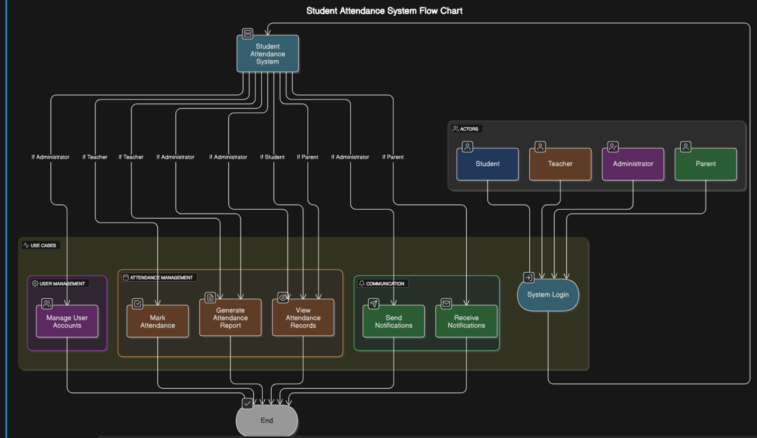

3.5 Object Model

3.5.1 Data Dictionary
The data dictionary defines the key data elements used in the "Student Attendance System," their attributes, and relationships. Here’s an example of some essential data elements:
Element | Description | Attributes | Example
Student | Represents a student in the system. | ID, Name, Grade, Attendance | ID: 123, Name: Y
Class | Represents a class/session. | ID, Subject, Teacher, Students | ID: ENG101, Teacher: Mr. X
Attendance | Represents attendance records. | Date, Status, Student ID | Date: 16-April, Status: Present
User | Represents system users. | ID, Name, Role, Credentials | Role: Teacher, Admin
Notification | Represents alerts sent to users. | Type, Recipient, Message | Type: Absentee Alert
These elements form the backbone of the system’s data structure.

3.5.2 Class Diagram
The class diagram represents the structure of the system by defining its classes, attributes, and relationships. Here’s how the key elements of the "Student Attendance System" would look:
Classes:
- Student
  - Attributes: StudentID, Name, Grade, ClassID
  - Methods: ViewAttendance()
- Class
  - Attributes: ClassID, Subject, TeacherID, StudentList
  - Methods: ManageClass()
- Attendance
  - Attributes: Date, Status, StudentID, ClassID
  - Methods: RecordAttendance()
- Teacher
  - Attributes: TeacherID, Name, ClassID
  - Methods: MarkAttendance(), GenerateReport()
- Administrator
  - Attributes: AdminID, Name, Role
  - Methods: CreateUser(), ManageUserAccounts()
- Notification
  - Attributes: NotificationID, Type, Recipient, Message
  - Methods: SendNotification()
Relationships:
- Association between Student and Attendance: A student is linked to multiple attendance records.
- Composition between Class and Student: A class contains a list of students.
- Aggregation between Teacher and Class: A teacher manages multiple classes.
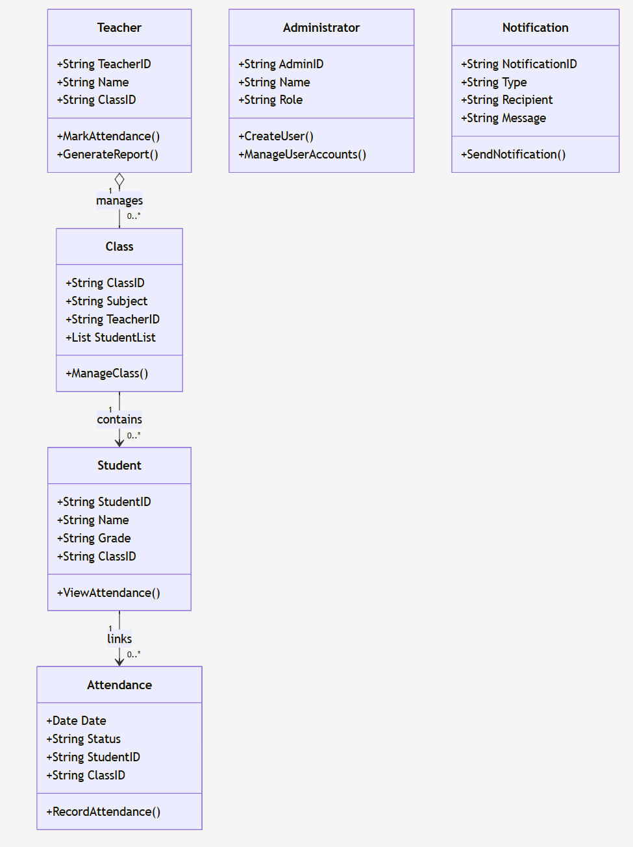

3.6 Dynamic Model

3.6.1 Sequence Diagram
The sequence diagram represents the interaction between objects in a time-ordered sequence to achieve a specific functionality. Here's an example for "Mark Attendance":
- Actors/Objects Involved:
  - Teacher
  - System Login
  - Attendance Database
  - Report Generator
- Sequence of Activities:
  - The Teacher logs into the system.
  - The system verifies credentials and grants access.
  - The Teacher selects a class and marks attendance.
  - Attendance data is stored in the database.
  - A confirmation message is sent to the Teacher.
Purpose: This diagram shows the order of interactions and how objects work together to fulfill the attendance marking use case.

3.6.2 Activity Diagram
The activity diagram depicts the flow of activities or operations in a process. Here's an example for "Generating Attendance Report":
- Start Node:
  - The Administrator initiates the report generation process.
- Flow of Activities:
  - The Administrator selects the class and reporting period.
  - The system retrieves relevant attendance data from the database.
  - The system processes and compiles the report.
  - The report is generated and displayed to the Administrator.
- End Node:
  - The Administrator views or exports the report.
Purpose: This diagram visualizes the step-by-step workflow for generating attendance reports.

3.6.3 State Chart Diagram
The state chart diagram represents the system's behavior and state changes in response to events. Here's an example for a "Student Attendance Record":
- Initial State:
  - Attendance record is in "Not Marked" state.
- Transitions:
  - When the Teacher marks a student as "Present," "Absent," or "Late," the record transitions to the corresponding state.
- Final State:
  - The record is marked and saved in the database.
Purpose: This diagram highlights how the attendance record changes state based on actions.

4. Chapter 4: System Design – Student Attendance System

4.1 Overview
The Student Attendance System is intended to automate the recording, monitoring, and reporting of student attendance in educational institutions. The design translates the system requirements into an organized architecture, ensuring seamless interaction between various components, efficient data handling, secure communication, and reliable performance across multiple devices and user types.
The system is aimed at educational institutions of various sizes — from small schools to large universities — allowing flexible configuration and customization to institutional policies and workflows.

4.2 Purpose of the System Design
The design serves as a detailed blueprint for developers, administrators, and stakeholders to understand the system’s architecture, data management policies, user interaction patterns, security mechanisms, and deployment strategies.
The key goals of this design are:
- To ensure that the system is secure, scalable, and robust.
- To create a user-centric experience across various platforms.
- To allow flexibility for future feature enhancements and technology upgrades.

4.3 Design Goals
- Accuracy: Ensure real-time, error-free attendance capture and data recording.
- Security: Protect sensitive student and institutional data using encryption, secure authentication, and role-based access control.
- Usability: Design intuitive interfaces suitable for users with minimal technical skills.
- Scalability: Support institutional growth, additional campuses, and increased user load without major redesigns.
- Maintainability: Modular codebase for easy updates, bug fixes, and feature enhancements.
- Auditability: Maintain comprehensive system logs for all critical activities (e.g., attendance modifications, user logins).

4.4 Proposed System Architecture

4.4.1 System Process Flow
- User Authentication: Users log in based on their roles (Admin, Teacher, Student, Parent).
- Attendance Management: Teachers select classes and mark attendance daily.
- Data Storage: Attendance records and user activities are securely stored in a centralized relational database.
- Report Generation: Admins and teachers can generate custom attendance reports based on date ranges, student/class selection.
- Notifications: Automatic alerts (e.g., absentee notifications) are triggered and sent to parents/students.
- Audit Trail: System logs actions for review by administrators.

4.4.2 Subsystem Decomposition and Description
- User Management Subsystem:
  - Registration, authentication (username/password or OAuth).
  - Password recovery, role assignment.
- Attendance Management Subsystem:
  - Daily attendance recording (Present, Absent, Excused).
  - Bulk attendance upload/download via CSV.
- Reporting Subsystem:
  - Attendance summaries (by student/class/date range).
  - Export options: PDF, Excel, CSV.
- Notification Subsystem:
  - Email, SMS, and in-app notifications for absenteeism, upcoming holidays, reminders.
- Audit Logging Subsystem:
  - Record critical events (logins, data edits).
- Database Subsystem:
  - Ensures data integrity and supports high-availability and backups.

4.4.3 Hardware-Software Mapping
- Client Devices:
  - Desktops, laptops, tablets, smartphones.
  - Web browsers (Chrome, Firefox, Safari, Edge).
- Application Server:
  - Django REST Framework-based backend.
  - Deployed on Linux servers (Ubuntu preferred) or containerized using Docker.
- Database Server:
  - MySQL or PostgreSQL for production.
  - SQLite used for development/testing environments.
- Notification Services:
  - SMTP servers (Gmail API, Amazon SES) for emails.
  - Twilio/other SMS gateways for text messages.

4.4.4 Persistent Data Management
All data entities are mapped into relational tables with appropriate constraints:
- Students ↔ Classes: Many-to-Many relationship.
- Attendance: Foreign keys to Student, Class, Teacher, Date.
- Users: Extend Django's built-in user model with role-based profiles.
- Referential integrity is enforced via ON DELETE CASCADE rules to maintain clean database relationships.
Backups:
- Scheduled full database backups daily.
- Transactional backups every 5 minutes (optional for high-availability setups).
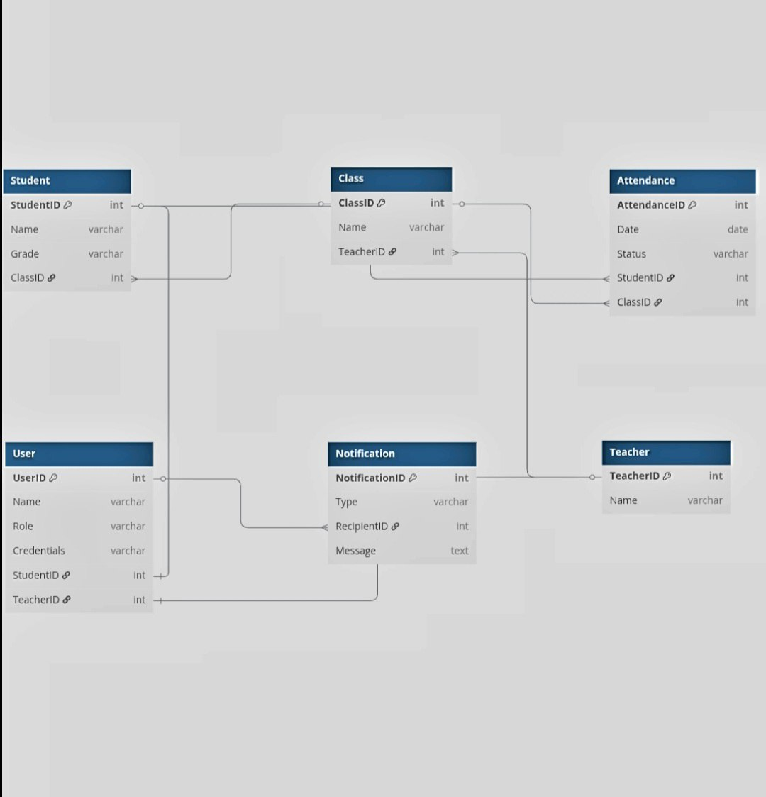

4.4.5 Component Diagram
The system is composed of six major components:
* User Interface: Facilitates interaction between the users and the system.
* Attendance Logic: Handles all processes related to tracking and managing attendance.
* User Management: Manages user-related operations, including registration, authentication, and role assignments.
* Reporting Module: Generates reports based on attendance data and user activity.
* Notification Service: Sends alerts and reminders via email, SMS, or in-app messages.
* Database: Stores user data, attendance records, and system logs.
Integration between components is achieved via RESTful APIs.
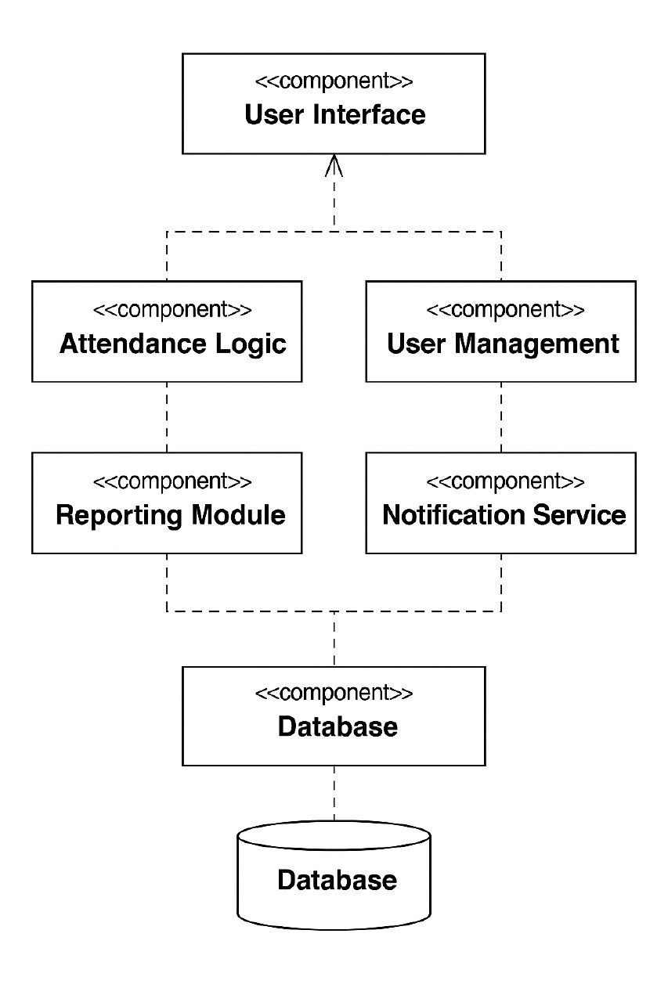

4.4.6 Deployment Diagram
- Client Layer:
  - Browser-based access; optionally wrapped into mobile apps via WebView or Flutter/PWA.
- Application Layer:
  - Django backend hosted on VPS, AWS EC2, Azure App Service, or similar platforms.
  - Load Balancer (NGINX) for scaling multiple servers.
- Database Layer:
  - MySQL database cluster with master-slave replication for fault tolerance.
- Storage:
  - Static and media files managed by cloud storage (AWS S3/Google Cloud Storage).
Deployment Modes:
- Single-server deployment for small institutions.
- Distributed deployment for large universities (multi-node setup).
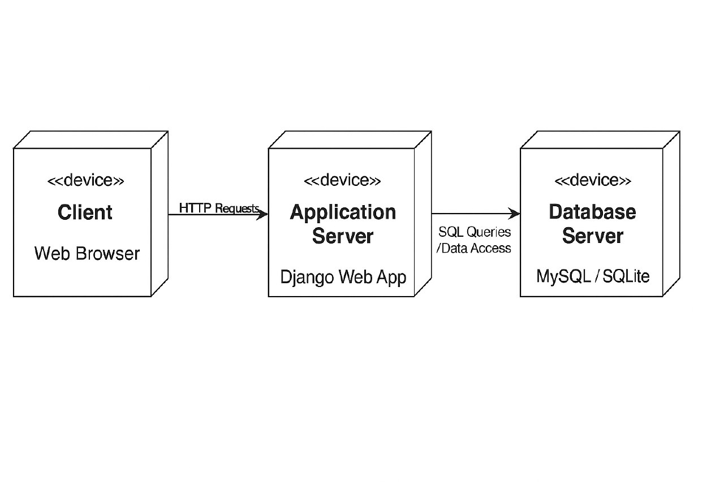

4.4.7 Database Design
The database contains the following core tables: Students, Teachers, Classes, Attendance, Users, Notifications. Each table includes primary keys, and relationships are enforced with foreign keys. Indexing improves data access performance.
. Indexes: Applied on Student ID, Class ID, Date for Attendance table to optimize search queries.
- Views: Materialized views for commonly accessed reports .

4.4.8 Access Control
Role-based Access Control (RBAC) is implemented:
- Admins:
  - Full CRUD access over all modules.
  - Manage users, settings, and system configurations.
- Teachers:
  - Restricted access to their assigned classes and students.
  - Cannot modify other teachers' data.
- Students/Parents:
  - View-only access to their own records.
  - Notification subscription options.
Session timeouts and two-factor authentication (2FA) are recommended for higher security.

4.4.9 User Interface
- Dashboard:
  - Attendance percentages, absentee trends, upcoming events.
- Attendance Page:
  - Class-wise student lists with checkboxes for present/absent.
  - Bulk marking and quick filters (e.g., “Mark All Present”).
- Reports Page:
  - Advanced filters by class, student, date.
  - Graphical charts (line/bar graphs) for visualization.
- Login/Registration:
  - Mobile-responsive, supports social login (optional).
- Notification Center :
  - In-app messages and alert history for users.
- Responsive Design:
  - Adapts to various screen sizes using frameworks like Bootstrap or Tailwind CSS.

